Error bar in bar plot:

Error bars are graphical representations in fig(1) of the variability of data and used on graphs to indicate the error or uncertainty in a reported measurement.

They give a general idea of how precise a measurement or conversely, how far from the reported value the true (error free) value might be.

Error bars often represent one standard deviation of uncertainty, one standard error, or a particular confidence interval.

These quantities are not the same and so the measure selected should be stated explicitly in the graph or supporting text.

Uses of error bars in bar plot:

1. compare visually two quantities if various other conditions hold.
2. determine whether differences are statistically significant.
3. suggest goodness of fit of a given function, how well the function describes the data
4. Scientific papers in the experimental sciences.
5. direct manipulation interface for controlling probabilistic algorithms for approximate computation.
6. expressed in a plus–minus sign (±), plus the upper limit of the error and minus the lower limit of the error.

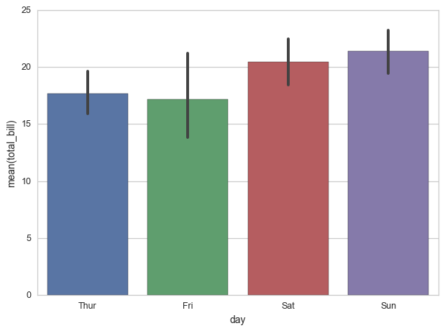

Fig (1)

References:

<https://en.wikipedia.org/wiki/Error_bar>

<https://datascience.stackexchange.com/questions/8645/python-seaborn-how-are-error-bars-computed-in-barplots>